1. **CAD of buggy**

Screenshots and brief description of the buggy design are given below.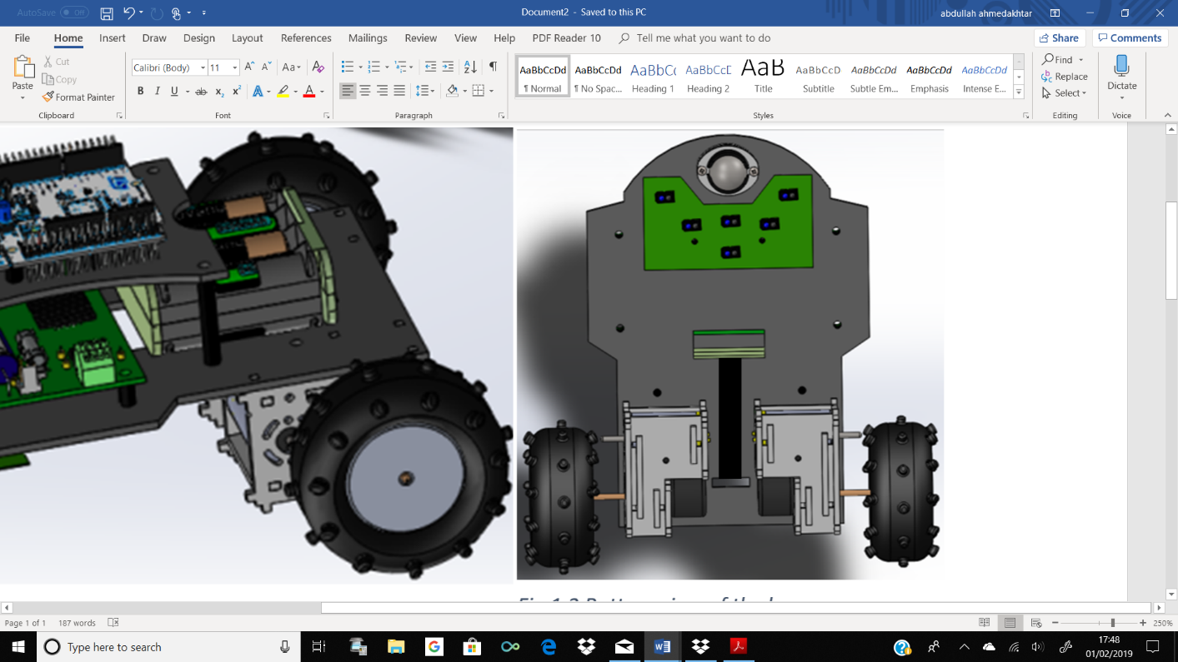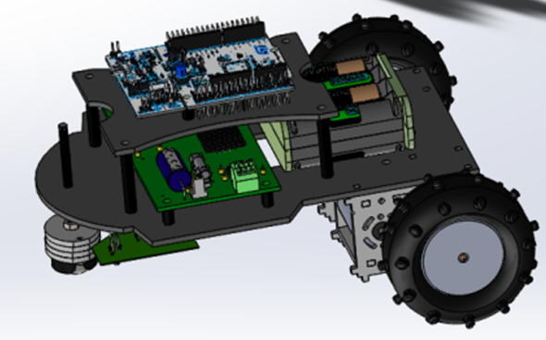

Fig 1.2 Bottom view of buggy

Fig 1.1 CAD of buggy

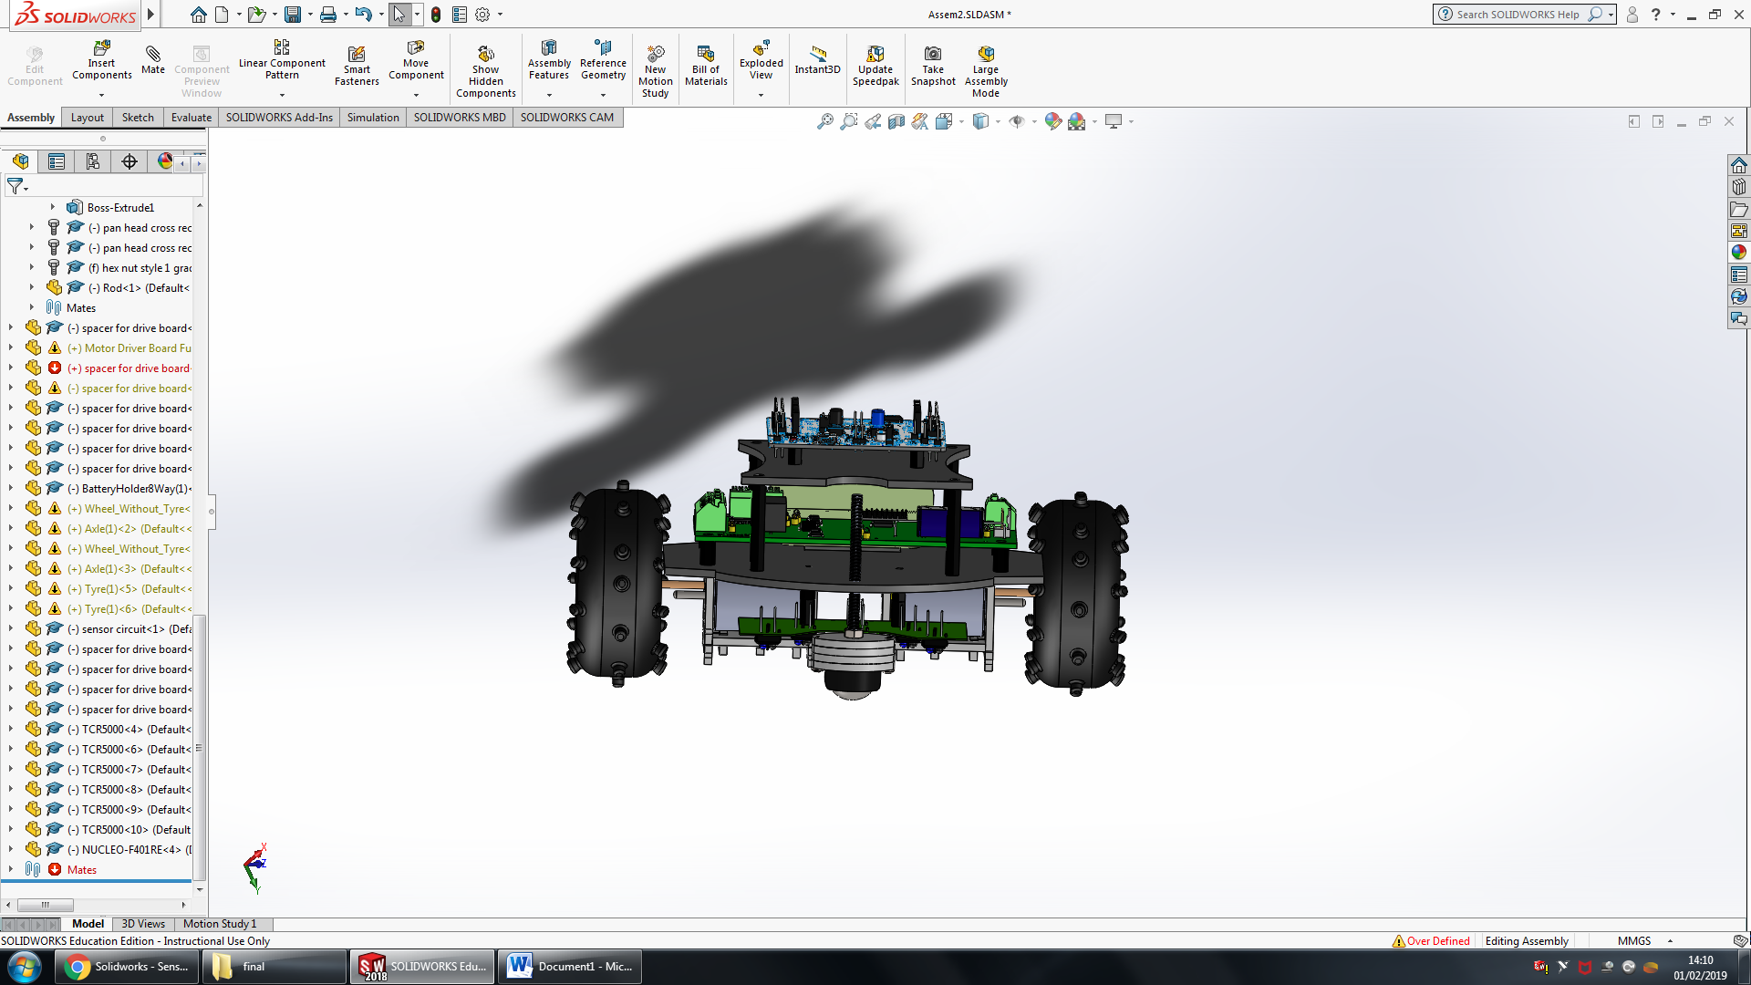

Fig 1.4 Front view of the buggy

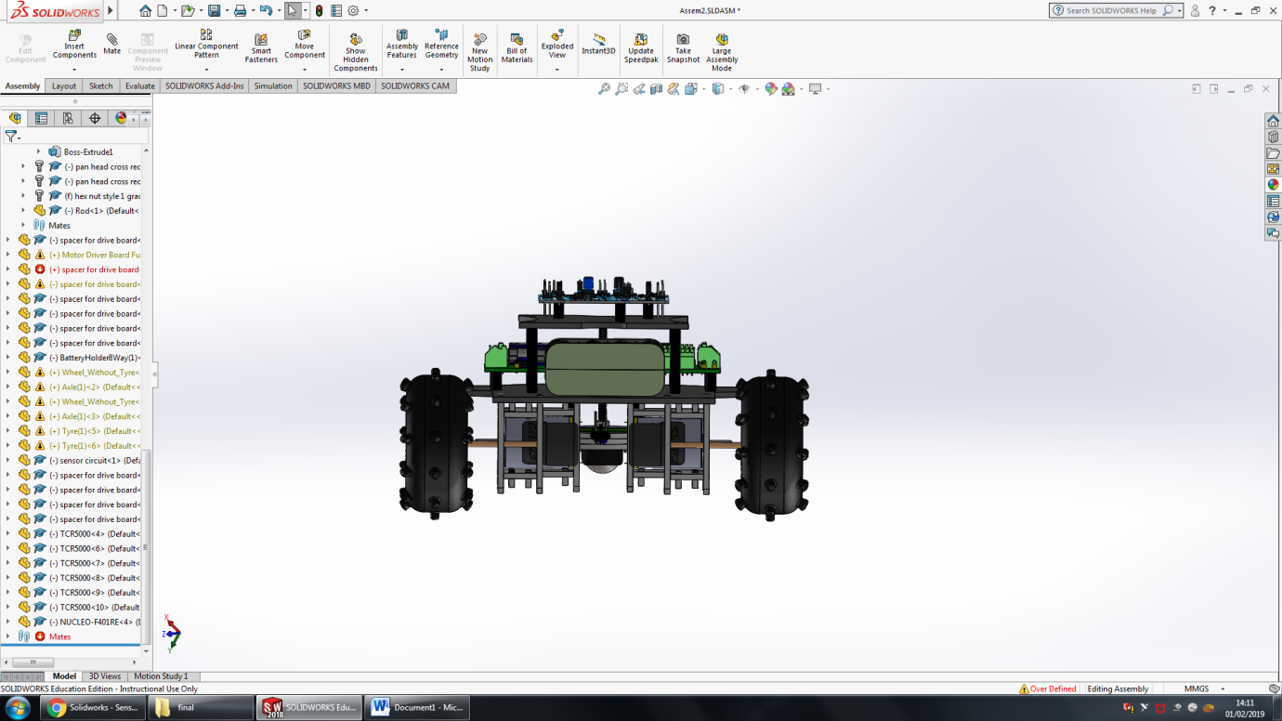

Fig 1.3 Back view of the buggy

As can be seen in fig 1.1, buggy design consists of two plates upper and lower. Upper plate only consists of the nucleo board and is connected to the lower plate using spacers, length of spacers is such that the gap between lower and upper plate is big enough to fit part of battery pack (shown in fig 1.1). Gearbox, sensor circuit and ball castor fit under lower plate, battery pack and motor drive board are on top of the lower plate as shown in fig 1.2 and 1.1 respectively. Two rectangular holes (large hole in the centre and small hole between gearboxes) have been cut in the lower plate shown in fig 1.2. Battery pack is placed between these holes and Velcro strip threads through the holes and around battery pack to secure it to the plate. The larger rectangular hole is also used for wires to go through from components under the plate to above e.g. wire from motor (under the plate) to the motor drive board (top of lower plate).